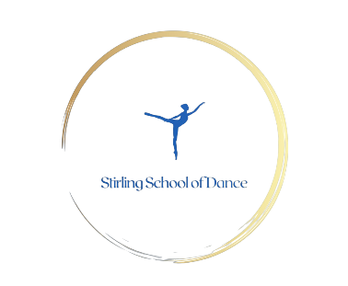

Class Registration Form

|  |
| --- |
| Childs First Name ……………………………. Surname ……………………………. Gender M / F  DOB …… /…… /……  Any medical conditions/allergies ………………………………………………………………………………………………  Parent/Guardian First Name ……………….………………… Surname …………………………………………………  Address ……………………………………………….. Contact Number ………………………………………………...  ……………………………………………….. Email : ………………………………………………………………..  ………………………………………………..  Post Code ……………………………….  Do you consent to videos/photos being taken only by the teacher during class to be shared with their parents? Y / N  Do you consent to photos being taken and shared in a closed Facebook group? Y / N  Do you consent to photos being taken and shared on social media? Y / N  Do you give permission for first aid? Y / N  Cardinal Newman Classes only  Will your child be attending an afterschool club at CN before their lesson? Y / N  If yes please state whether they will be brought to the class by a parent/guardian, by the club themselves or by their ballet class teacher(if pre primary/standard1).  ……………………………………………………………………………………………………………………………  Will your child be attending an afterschool club at CN AFTER their ballet lesson? Y / N  If yes please state which club will be picking them up. …………………………………………………………………………………………………………………………..  If not attending a CN club please state who is likely to be picking your child up after their class.  …………………………………………………………………………………………………………………………… |

Email : [Phoebe@StirlingDance.co.uk](mailto:Phoebe@StirlingDance.co.uk) [www.StirlingDance.co.uk](http://www.StirlingDance.co.uk)